**Public perceptions of landslides in Himachal State**

**Motivation:** Landslide i.e. the mass movement of rock, debris or earth down a slope is a natural disaster which is affecting almost all continents of the world. Landslides cause massive damage to life and property and often snap major communication links causing massive disruption in transport / supply network. Himachal Pradesh is extremely vulnerable to natural disasters due to its fragile geology, active tectonics, high relief, critical slopes and intense rainfall. Currently, there is lot of technological and engineering research on developing mitigation options for landslide. Some of these technological options include developing sensor based early warning systems, geo-engineering, etc. However, as the decisions to adopt different technological and engineering options ultimately rests with people, therefore, research that studies the role of people, their understanding of landslide disaster, and their wait-and see behavior on disaster occurrence is also critically needed, though currently lacking in the literature. **Objectives:** the main purpose of this thesis is to investigate from a cognitive perspective the following research questions: Q1: Evaluation of public perception of landslide risk? Q2: Furthermore, is there a way to influence people‘s wait-and-see behaviour through certain manipulations? **Methodology:** The approach involves evaluating the basic knowledge, risk perception and attitude of people towards landslide risk by systematically manipulating certain conditions and collecting behavioral data, where human participants make judgments and choices on landslide risk problems.**Implications:** Investigating the role of certain cognitive factors that are likely to influence people‘s wait-and-see behavior on landslide risk will help improve risk awareness among the people and provide better decision support to policy makers in countering risk due to landslides.



Fig. Landslide in Khaliyar (Mandi) (2007)

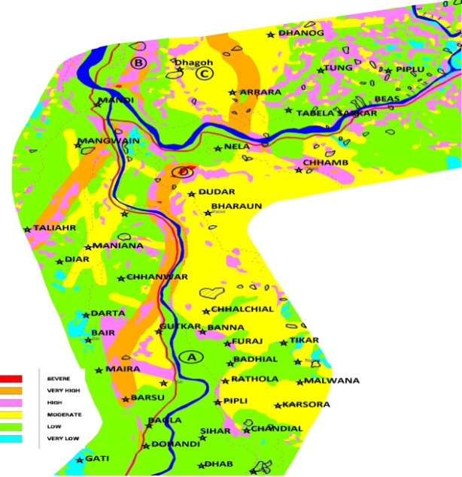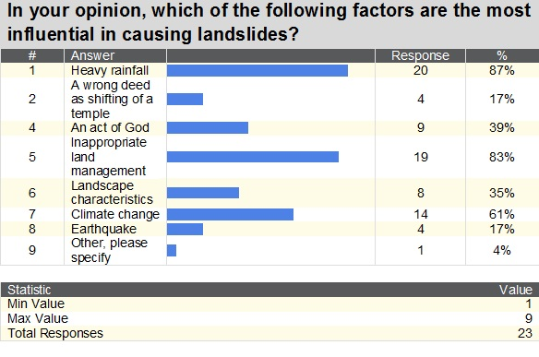

landslide Susceptibility Map of Mandi district, H.P. Some Results of survey conducted at Mandi

